Ideation Phase

Define the Problem Statements

|  |  |
| --- | --- |
| Date | 19 September 2022 |
| Team ID | PNT2022TMID42501 |
| Project Name | Project – Smart Fashion Recommender Application. |
| Maximum Marks | 2 Marks |

# Customer Problem Statement Template:

Create a problem statement to understand your customer's point of view. The Customer Problem Statement template helps you focus on what matters to create experiences people will love.

A well-articulated customer problem statement allows you and your team to find the ideal solution for the challenges your customers face. Throughout the process, you’ll also be able to empathize with your customers, which helps you better understand how they perceive your product or service.

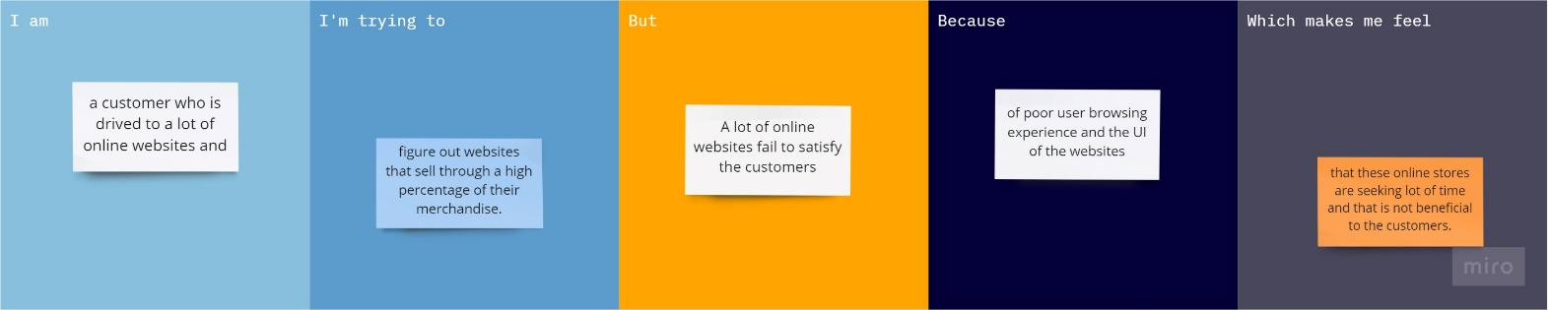

|  |  |  |  |  |  |
| --- | --- | --- | --- | --- | --- |
| **Problem**  **Statement (PS)** | **I am**  **(Customer)** | **I’m trying to** | **But** | **Because** | **Which makes me feel** |
| PS-1 | a customer who is drived to a lot of online websites and | figure out websites that sell through a high percentage of their merchandise. | A lot of online websites fail to satisfy the customers | of poor user browsing experience and the UI of the websites | that these online stores are seeking lot of time and that is not beneficial to the customers. |
| PS-2 | A Fashion expert and | Get the best outfit | Am unable to go with the trend | The app do not differentiate with the general and the expert customer | That online shopping is not preferrable. |